Ali Al-Hilo  
&  
Talal Saleh

**Electricity consumption and market price forecasting Using machine learning**

Future Electricity and Energy Markets and Business concepts

Vaasa 2020

**Contents**

1 Abstract 4

2 Introduction 5

2.1 Overview of LSTM(Long Short-Term Memory) network 6

2.2 Overview of Multi-layer perceptron regressor 9

3 Methodology 11

3.1 Datasets 11

3.2 Energy forecasting using LSTM 15

3.3 Market price forecasting using LSTM 17

3.4 Energy forecasting using MLPR 19

3.5 Market price forecasting using MLPR 22

3.6 Comparison of two models 25

4 Conclusion 26

5 Bibliography 27

6 Appendices (separately attached) 30

6.1 Appendix 1. data.csv 30

6.2 Appendix 2. Jupyter Notebook MLPR model .ipynb 30

6.3 Appendix 3. Jupyter Notebook LSTM model.ipynb 30

Figures

Figure 1. LSTM construction 7

Figure 2. MLP architecture (Choubin, B., 2016). 9

Figure 3. 2019 and 2020 energy consumption 12

Figure 4 Energy distribution 13

Figure 5. Hourly energy consumption 13

Figure 6. 2019 and 2020 market price 14

Figure 7. Market price distribution 15

Figure 8. Hourly market price 15

Figure 9. Training loss Vs validation loss for electricity consumption 16

Figure 10. Actual Vs predicted consumption a. train set, b. test set 17

Figure 11. Training loss Vs validation loss for Market Price 18

Figure 12. Actual Vs predicted consumption a. train set, b. test set 18

Figure 13. 2019 Features for energy forecasting 20

Figure 14. Energy forecasting model performance. 20

Figure 15. Energy forecasting year 2019 21

Figure 16. 2019 Features for market price forecasting 22

Figure 17.Market price forecasting model performance. 23

Figure 18. Market price forecasting year 2019 23

Figure 19. March 2020 market price forecasting 24

Figure 20. April 2020 market price forecasting 24

Tables

Table 1 Energy forecasting accuracy comparison 22

Table 2 Market price forecasting accuracy comparison 23

# Abstract

*The fluctuation in electricity consumption and price has increased rapidly during the past half-decade. This is considered a very big challenge that affects both the power supplier and the consumer. However, electrical utilities need to estimate the future consumption and price behavior of their customers and beforehand based on prior knowledge learnt from data. There are different types of prediction tools in machine learning that have been developed, used and succeed in providing enough accurate results. In this paper, we utilized market price and energy consumption data from Fingrid and Nordpool for around 1.5 year. Two regression techniques including (MLPR) Multi-layer perceptron regressor and LSTM (Long-short Term Memory) algorithms were applied to predict the energy demand and the market price of Finland****.***

# Introduction

Increase in human population and technological advancement has created an increase in demand of electricity. Electricity demand and supply curve fluctuates which have an impact on the stability of power system. Integration of distributed energy resources (DERs), complex loads and latest demand response technologies on demand side such as electric vehicles and IoT has further aggravated power system dynamics (Zhao, J., Gómez-Expósito, 2019). Balancing supply and demand will become more challenging in the future especially when considered along with the increase in renewable energy resources (Boßmann, T., & Staffell, I. 2015).

To ensure power system stability and reliability they are planned to be operated and controlled to deal with the power system dynamics (Zhao, J., Gómez-Expósito, 2019). Control of power system depends upon the load demand. Energy from various generators may be fed into the system or removed from the energy network based on the electricity demand. To manage load, system reliability and stability energy forecasting can play a great part which could help in pre-planning the system operation which will help in balancing energy supply and demand.

The rising attitudes towards liberalized market regimes and the rapid growth of generating electricity from renewable sources, increase the volatility and the uncertainty in the electricity market (Beigaite;Krilavičius;& Man, 2018). However, there are many factors that affect the electricity price including, the generation costs, the changes between supply and demand, number and sizes of competitors in the market, and the governmental policies. These factors result in seasonality, massive fluctuations and spikes in the electricity price and make the prediction of MCP (market cleaning price) complex task. Hence, the electricity price forecasting (EPF) become an important topic for researchers and all markets players (i.e., producers, investors, traders and buyers/end users) in electricity market (Jiang & Hu, 2018).

There are four categories of forecasting the electricity price depending on the time horizon. First is the dynamic/real-time category also known as Very Short Term Price Forecasting (VSTPF). It is used for real time prediction to allow the customers reducing their consumptions and the costs of the electricity. The second category is the short-term forecasting, which range between few minutes to few days ahead price forecasting. It assists the producer and retailer to define their bidding price for the spot market to calculate their profits and risks. The medium-term category, which is used to forecast a span from few weeks to a few months ahead, allow market practitioners to arrange contract policies, scheduling maintenance for generation companies, and budgeting and fuel contracting (Torghaban;Zareipour;& A., 2020). Finally, the long-term category, which refers to one year or more ahead forecasting, assists the investors, producer and retailers to determine the expansion plans of their organizations (Mujeeb;Javaid;& Javaid, 2018).

This paper focuses on forecasting two months ahead of both electricity market price and the energy demand of Finland. Although there are different factors that affect the price of electricity and the energy demand, this paper will consider only the historical market price and energy data and neglects all other factors . This is because the limitation in the ability of the computers that are used for doing forecast in this paper.

Two algorithms are used in this paper to implement the forecasting. The first is LSTM (Long Short-Term Memory) method and the second is MLPR.

## Overview of LSTM(Long Short-Term Memory) network

One of the most significant characteristics of the human brain is the ability of utilizing long and short memory to analyze previous information and connect them to the present task. Hence, RNN (Recurrent Neural Network) has introduced to make use of sequential information and simulate this ability of human brains . All RNNs have feedback loops in the recurrent layer. This allows them maintain information in 'memory' over time. But it has been proved in practice when the gap between the previous information and present problem grows most of RNNs fail to keep what it seen in longer sequences  (Bengio;Simard;& Frasconi, 1994). This is because the vanishing or exploding gradient problem. Hence, LSTM neural network has been proposed in 1997 by Hochreiter and Schmidhuber to handle tasks that consider long-term dependencies (Hochreiter & Schmidhuber, 1997). It is a supervised machine learning algorithm depends on the recurrent neural network (RNN) concept. It is a successful algorithm in sequential tasks which overcomes other neural networks in different points such as vanishing/exploding gradient problem (Chandramitasari;Kurniawan;& Fujimura, 2018).

LSTM is a type of RNN that uses special units in addition to standard units. Each LSTM algorithm could contain one or more of the LSTM cells. Each cell has three gates that are highly similar to each other in shape. These gates are able to memorize the data according to their importance. So that the data with high importance will be kept, while the others will be forgotten. The aim of this process is to pass the most relevant information to the second layer . Figure.1 shows the simple construction of one LSTM unit.

Figure 1. LSTM construction

In the following, the component of the LSTM cell and the equation of each component will be explained.

*Forget gate:*

This gate controls the information that are passed form the previous hidden layer (*ht-1*) and from the current input (*xt)* and decide which information to forget or to pass for the cell state. *.* The concatenation vector of *ht-1* and *xt* will subject to sigmoid function. The output of sigmoid function (*ft*) will range between 0 and1, if the output value is closer to 0 then the information will be thrown away and vice versa. The cell state will be updated in this stage by point-wise production (*ft*) with the previous layer output (*Ct-1)* The equation below represents the mathematical construction of this gate. *Wx* refers to the weight of the input vector *Xt,, Wh* stands for the weight of previous hidden layer and *bf* is the bias of this layer.

*The input gate:*

This gate is used to update the cell state. First, both the current (*xt*) and the previous state (*ht-1)* are fed into a sigmoid function to define the values that will be updated. Next (*xt*) and (*ht-1)* will be passed to tanh layers which produce output between 1 and -1 in order to regulate the network. The output of both functions would be multiplied to allow the sigmoid function deciding the most important data. The production of sigmoid and tanh function will combine with current state (*Ct-1* ft*) to create the cell output (*Ct*). The output of input gate can be represented by the following equation

*Output gate:*

The output gate determines the next hidden state, The last cell state values (*Ct*) will subject to tanh function while the current input values (*xt*) will be modified by sigmoid function which result *ot*. The output of tanh will be multiplied by *ot* to produce the next hidden state (*ht*).

*Cell State:*

The function of this component is to transfer the relevant data across all time steps to the next layer. The transferred data depends on the output of input and forget gates, and previous cell state as explained previously. [1]

## Overview of Multi-layer perceptron regressor

Multi-layer perceptron network is a class of feedforward artificial neural network (ANN) which are mostly used for machine learning and data mining. Feedforward neural networks (FF NN) are also the first ever devised neural networks (Schmidhuber 2015). MLP is a supervised learning method which requires certain set of datasets which will be used to predict future outcomes or classes. It can be used for both classifications, in which classes for any data sets can be predicted, or for regression to predict numeric results.

MLP consists of three layers namely input layer, hidden layer and the output layer. Similar to a human brain, or a neural network, the layers consists of neurons. These neurons are arranged in each layer and are connected only with the neurons of the former layer which all together builds up a perceptron; no neurons in the same layers are interconnected (Choubin, B., 2016). The number of neurons in the input layer depends upon the data fed into it; the hidden layer can be one or more whereas the output layer consist of neuron having the result produced. The basic architecture of MLP network can be seen in figure 1.

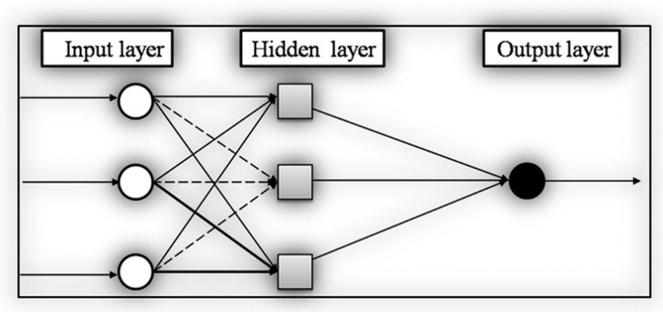

Figure 2. MLP architecture (Choubin, B., 2016).

MLP uses back-propagation training algorithm (Ramchoun, H., 2016). Generally, to produce the output the flow of process is from input layer to output layer in forward direction, which is also called forward propagation. But the backward propagation allows the flow in backward direction to compute the gradient of a loss function (Goodfellow, I., 2016). It helps in tuning the weight of the network which reduces the error rate. Mathematically output value of the neurons in MLP can be represented as,

𝒚 = 𝒇(𝒖)

Where 𝒚is the output of neurons, 𝒇 is activation function and 𝒖 is the sum of all weights multiplied all input values.

𝒖 **=**

# Methodology

The main objective of methodology in this paper is to forecast the electricity consumption and electricity market price in Finland. The forecasting consider historical time series data of an hourly electricity consumption and market price, to predict two months in an hourly base of market price and electricity consumption separately. Two neural network algorithms are used to achieve this purpose. Each of these methods train the same data, but with different features for each. In the following sections the data will be studies and visualized to discover the trends and the patterns that are involved in it. Then the model of each algorithm will be explained and after that the results will be discussed.

## Datasets

Finland’s datasets of hourly energy consumption and the market price in euro, for the year 2019 & 2020, were obtained from Fingrid and [NordPool](https://www.nordpoolgroup.com/elspot-price-curves/) respectively. Annual energy consumption and market price were visualized to understand the pattern which is carried out on monthly and hourly basis.

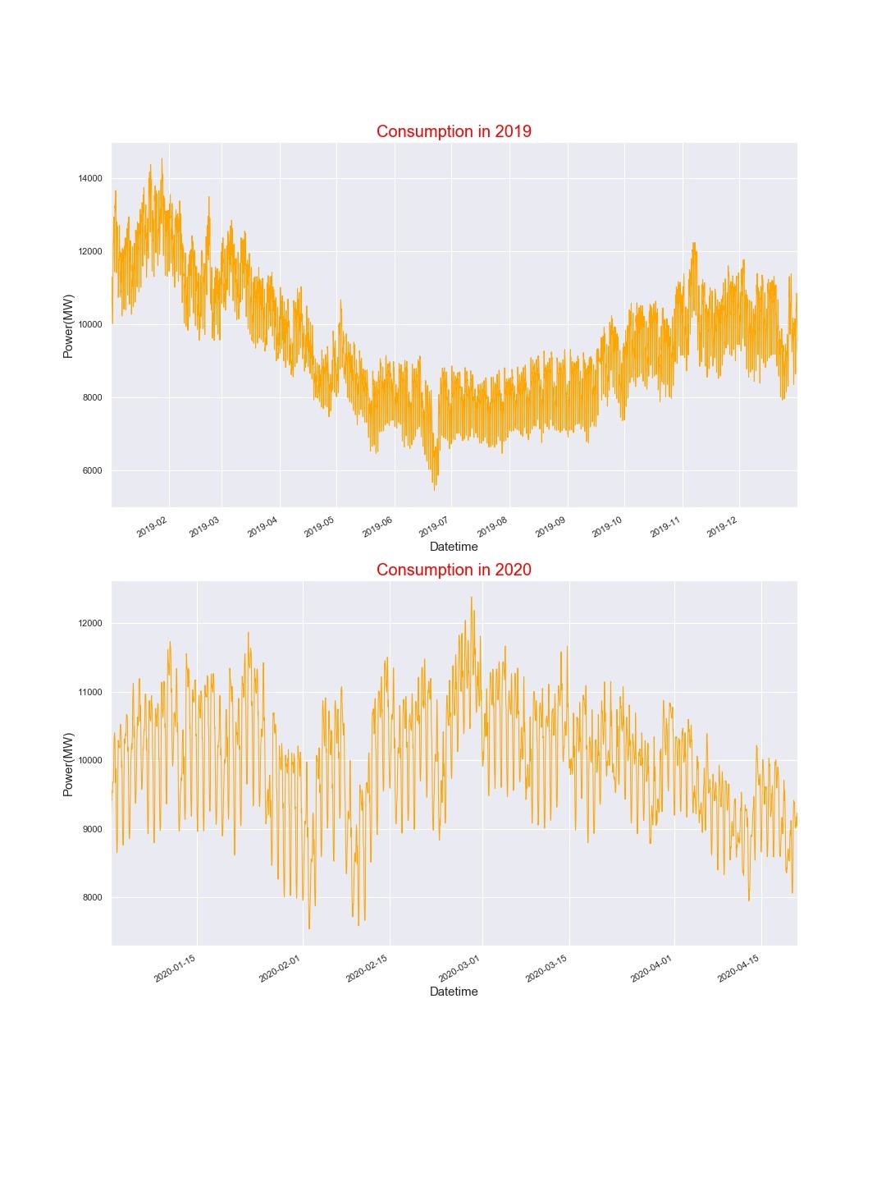

Figure 3. 2019 and 2020 energy consumption

From the year 2019 consumption it can be seen that Finland energy consumption during winters are higher as compared to the summers. Further visualization were carried out to see how much MW of energy is mostly consumed in Finland. It can be seen in the figure# that in Finland usual amount of energy consumption lies between 8000-10000 MW of energy.

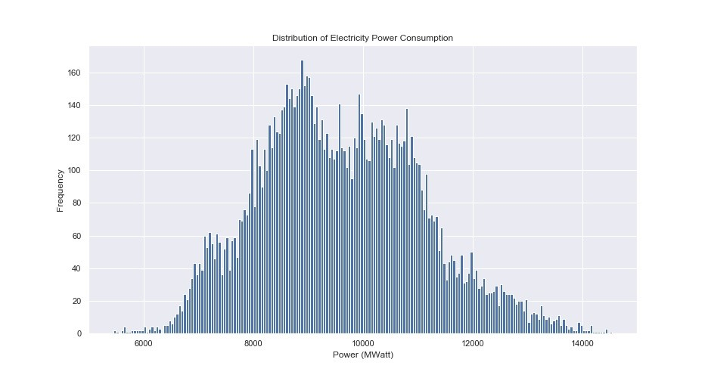

Figure 4 Energy distribution

Energy consumption usually varies based on hours. At some point of a day the energy consumption is higher (i.e., during peak hours) as compared to other hours. It can be seen that the energy consumption starts to rise in morning and remains higher till evening.

Figure 5. Hourly energy consumption

Similarly, the market price datasets were also visualized based on yearly market price, distribution of market price and hourly market price in euro.

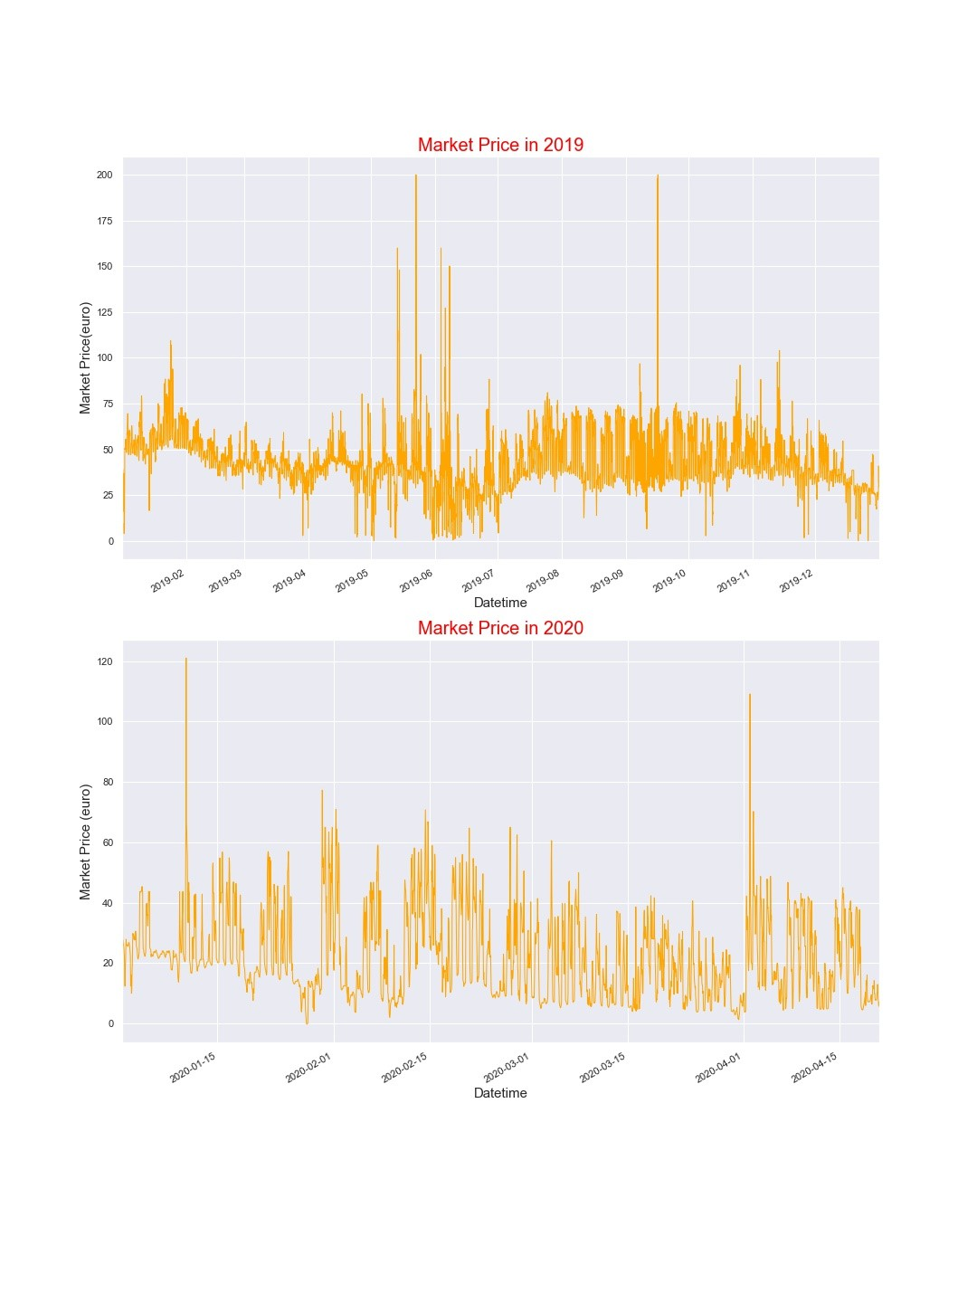

Figure 6. 2019 and 2020 market price

The market price distribution usually lies between 25-50 euro per hour. Further it can be seen in figure# that market price is usually higher for 15-20 hours.

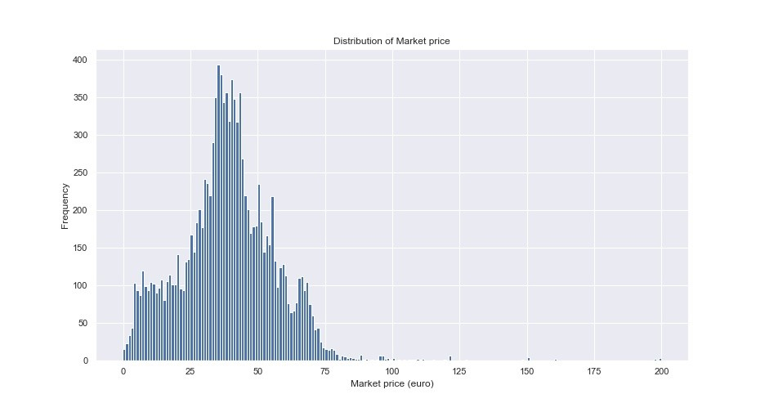

Figure 7. Market price distribution

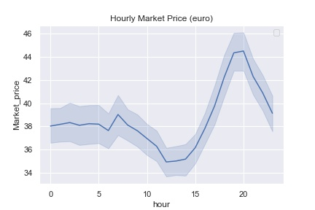

Figure 8. Hourly market price

## Energy forecasting using LSTM

After preparing and cleaning the data, they have been subjected to scaling function. The scaled data allow the neural network to learn the problem faster in more effectively manner. The data is scaled using (standardscaler()) function from scikit-learn library. Then 80 % of the data was reserved for training the model and the rest is hold-out for testing. The training data consists of two features which are energy consumption and market price, to predict energy consumption. The data then shaped in a way that LSTM network will take the first 10 samples to predict the eleven one and so on for all samples in train set.

The model consists of 2 hidden layers with 64neurons for the first layer and 32for the second one. Each of the layers use ReLU function as an activation function. The model is fit using the efficient ADAM optimization algorithm and the mean squared error loss function.

The model is iterated for 20 times (epochs=20), with batch size of 50 samples.

It learns the data very effectively and shows excellent results in term of loss and validation functions. the figure 9 below illustrates the progress of these values across the time of running the model for predicting the energy consumption.

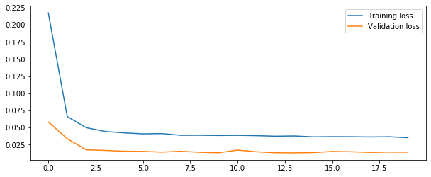

Figure 9. Training loss Vs validation loss for electricity consumption

The following figures 10.a and 10.b shows the predicted train data comparing to the real train set. And the predicted test data comparing to the real test data respectively.

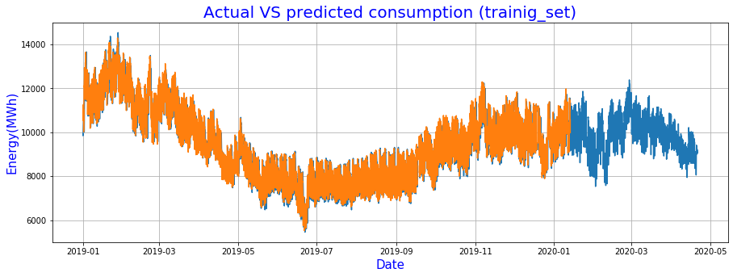

a

b

Figure 10. Actual Vs predicted consumption a. train set, b. test set

## Market price forecasting using LSTM

For predicting the market price, the same length of train data has been used. These train data is injected to the same model that is used in predicting energy.

However, the results show lower accuracy comparing to the accuracy of energy consumption prediction. Figure 11 shows the training loss comparing to the validating loss. Both values stay in range of 15% after the second iteration.

**Figure 11.** Training loss Vs validation loss for Market Price

The predicted train set scored 88% of accuracy while the test set results in 78%. Figure 12.a below explains the predicted values of the train set comparing to the actual market price values. Figure 12.b represent the predicted values of the test set comparing to the actual market price values for two months starting from 20.2.2020 to 20.4.2020

a

b

Figure 12. Actual Vs predicted consumption a. train set, b. test set

## Energy forecasting using MLPR

For energy forecasting the second method which is used in this study is the multi-layer perceptron regressor. To train a model using MLPR requires an activation function which defines the output of a node is used. The working of an activation function is similar to a digital signal which will activate a node (i.e., “0 (OFF)” or “1 (ON)”). Different activation function can be used in nodes such as logistics, tanh and relu. The activation function used in this study is rectified linear unit (ReLU) as they are found to have greater accuracy in statistical regression (Ghorbani, B., 2020) which is also the subject of this study. ReLU activation function is represented mathematically as,

Another parameter which influences the prediction of the output is the solver which optimizes the weight of the ANN. The model trained in this study uses L-BFGs solver which according to one of the studies when observed against number of hidden layers produces minimal errors when trained with MLP as compared to other solvers such as SGD and Adam (Lorencin, I., 2019). Another benefit of Limited-memory Broyden–Fletcher–Goldfarb–Shanno (L-BFGs) is that it uses low memory and can be applied to large datasets.

The model trained for forecasting energy consisted of four hidden layers with different number of neurons. For forecasting energy, a study is conducted to use market price and certain other features to predict the hourly energy consumption.

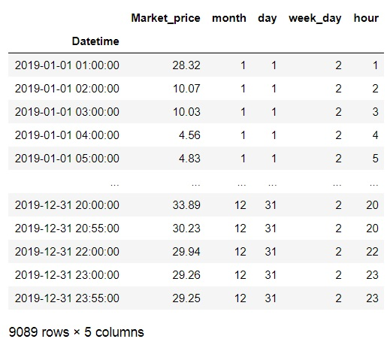

Figure 13. 2019 Features for energy forecasting

A model was trained with 2019 features against the target variable (i.e. 2019 energy consumption). Datasets were splitted into train and test sets using train_test_split function with shuffle=’True’. The data was passed into a pipeline which first scales the it and then trains the model using mlp regressor. The model was able to acheive 94% accuracy.

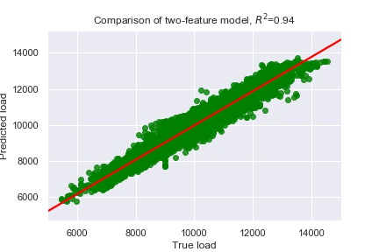

Figure 14. Energy forecasting model performance.

The model performance figure shows that mlp regressor model was able to form a linear pattern between features and target values. using mlp.predict(X_train) the training sets consisting of features2019 (75%) were used in predicting the target value (i.e., energy consumption 2019)

**Figure 15.** Energy forecasting year 2019

The study is conducted to forecast March and April 2020 hourly energy consumption. Features of year 2020 were then used to forecast energy using mlp.predict(). Following figures below shows the actual vs. predicted energy forecasts.

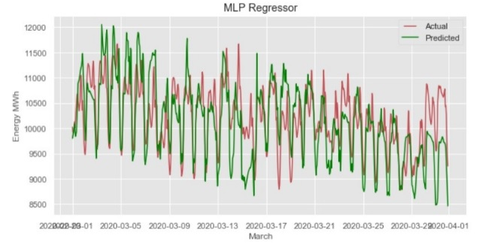

**Figure 16.**March 2020 energy forecasting

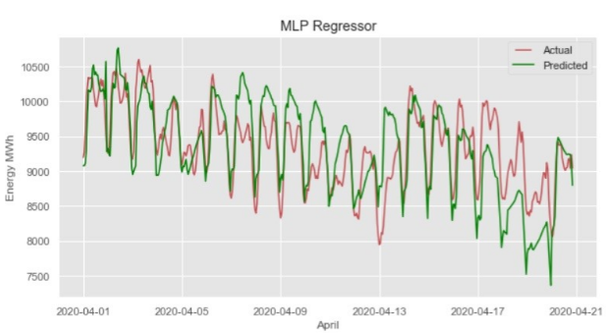  
**Figure 17.**April 2020 energy forecasting

## Market price forecasting using MLPR

For market price prediction, similar model of energy forecasting with same activation function, layers, neurons, and solver were used for training the market price forecasting model. It was suggested to conduct study of forecasting market price by using hourly energy consumption as a feature. The model was trained with 2019 actual load and certain other features such as day, month etc.

**Figure 16.** 2019 Features for market price forecasting

After training the model with above features, the model was able to acheive prediction accuracy up to 62%.

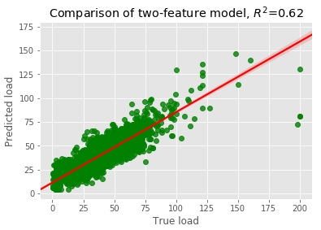

Figure 17.Market price forecasting model performance.

It can be seen that market price forecasting model was not able to accurately form a linear relationship between features and target value. To test the prediction, features of year 2019 were given to predict the target value i.e (market price of 2019)

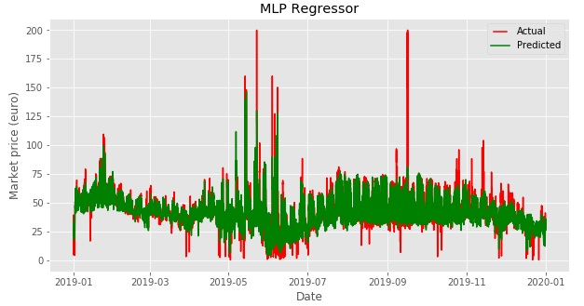

Figure 18. Market price forecasting year 2019

For forecasting of march and April 2020 market price features of 2020 were given to mlp.predict(). Following figures below are march and April prediction.

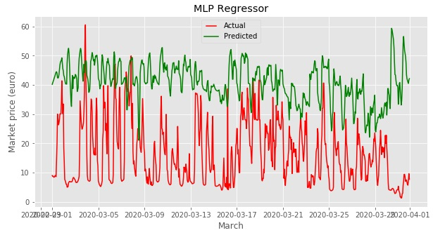

Figure 19. March 2020 market price forecasting

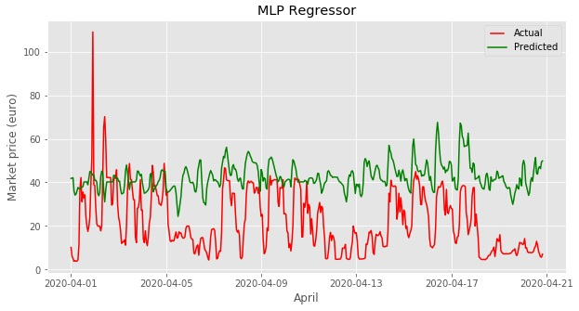

Figure 20. April 2020 market price forecasting

## Comparison of two models

After training the two models with the same data, we noticed that LSTM overcomes MLP regressor in the accuracy results in both energy consumption and market price predictions. in addition, LSTM is trained with only 2 features, while MLP regressor with more features.

Tables below shows the results of the two models. Table 1compare between the results of the model for energy consumption problem, while table 2 illustrates the results of the models in market price problem.

|  |  |  |  |
| --- | --- | --- | --- |
| Model | Cross validation score | Train score | Test score |
| LSTM |  | 0.98 | 0.96 |
| MLP regressor | 0.943922 | 0.945064 | 0.950134 |

Table 1. Energy forecasting accuracy comparison

|  |  |  |  |
| --- | --- | --- | --- |
| Model | Cross validation score | Train score | Test score |
| LSTM |  | 0.88 | 0.78 |
| MLP regressor | 0.616238 | 0.741184 | 0.644382 |

Table 2. Market price forecasting accuracy comparison

# Conclusion

The study suggested that market price can have a significant impact on forecasting energy consumption and vice versa. It was observed that when models were trained using market price for forecasting energy, high accuracies were achieved with both the models. However, for market price forecasting the LSTM model showed better performance as compared to the MLP regression model. LSTM also had higher accuracy in energy forecasting. Both the models were able to forecast two months hourly energy consumptions and the energy of March 2020 and April 2020 was forecasted.

However, to further improve the accuracies, specifically for MLPR model, other features can also be taken in consideration such as weather, oil prices etc. Low weather temperature or more snow can result in an increase in industrial and household load when heaters are turned on. Frequent visits to recreational places in winters such as saunas which operate by consuming more electricity can also be one of the reasons which causes peak in electricity demand.

As for forecasting market price of electricity, the oil prices could also be one of the reasons which cause fluctuation in market prices as oil generation still have some involvement of electricity generation in Finland. Other methods can also be adopted such as gathering datasets of different regions of Finland and forecast energy and price for separate region and then combine them all.

# Bibliography

1. Jiang, L., & Hu, G. (2018). Day-Ahead Price Forecasting for Electricity Market using Long-Short Term Memory Recurrent Neural Network. *15 th International Conference on Control, Automation, Robotics and Vision (ICARCV)* (pp. 949-954). Singapore: IEEE.

2. Beigaite, R., Krilavičius, T., & Man, K. L. (2018). Electricity Price Forecasting for Nord Pool Data. *International Conference on Platform Technology and Service (PlatCon)* (pp. 1-6). Jeju, South Korea: IEEE.

3.Mujeeb, S., Javaid, S., & Javaid, N. (2018). Data Analytics for Price Forecasting in Smart Grids: A Survey. *21st International Multi-Topic Conference (INMIC)* (pp. 1-10). Karachi: IEEE.

4.Torghaban, S. S., Zareipour, H., & A., L. (2020). Medium-term electricity market price forecasting: A data-driven approach. *North American Power Symposium* (pp. 1-7). Arlington,TX: IEEE.

5.Chandramitasari, W., Kurniawan, B., & Fujimura, S. (2018). Building Deep Neural Network Model for Short Term Electricity Consumption Forecasting. *International Symposium on Advanced Intelligent Informatics (SAIN)* (pp. 43-48). Yogyakarta, Indonesia: IEEE.

6.Bengio, Y., Simard, P., & Frasconi, P. (1994). Learning Long-term dependencies with gradient desecnt is difficult. *IEEE transactions in neural networks*, 157-166.

7.Hochreiter, S., & Schmidhuber, J. (1997). Long short-term memory. *Neural Computation*, 1735-1780.

8.Zhao, J., Gómez-Expósito, A., Netto, M., Mili, L., Abur, A., Terzija, V., ... & Huang, Z. (2019). Power system dynamic state estimation: Motivations, definitions, methodologies, and future work. IEEE Transactions on Power Systems, 34(4), 3188-3198. https://ieeexplore.ieee.org/abstract/document/8624411

9.Boßmann, T., & Staffell, I. (2015). The shape of future electricity demand: Exploring load curves in 2050s Germany and Britain. Energy, 90, 1317-1333. <https://www.sciencedirect.com/science/article/abs/pii/S0360544215008385>

10.Schmidhuber, J. (2015). Deep learning in neural networks: An overview. Neural networks, 61, 85-117. https://www.sciencedirect.com/science/article/abs/pii/S0893608014002135

11.Choubin, B., Khalighi-Sigaroodi, S., Malekian, A., & Kişi, Ö. (2016). Multiple linear regression, multi-layer perceptron network and adaptive neuro-fuzzy inference system for forecasting precipitation based on large-scale climate signals. Hydrological Sciences Journal, 61(6), 1001-1009. https://www.tandfonline.com/doi/full/10.1080/02626667.2014.966721

12.Ramchoun, H., Idrissi, M. A. J., Ghanou, Y., & Ettaouil, M. (2016). Multilayer Perceptron: Architecture Optimization and Training. IJIMAI, 4(1), 26-30. https://www.researchgate.net/profile/Youssef_Ghanou2/publication/292996667_Multilayer_Perceptron_Architecture_Optimization_and_Training/links/58318a1208ae138f1c076f8a/Multilayer-Perceptron-Architecture-Optimization-and-Training.pdf

13.Goodfellow, I., Bengio, Y., & Courville, A. (2016). 6.5 Back-Propagation and Other Differentiation Algorithms. Deep Learning, 200-220. https://www.deeplearningbook.org/contents/mlp.html#pf25

14.Ghorbani, B., Mei, S., Misiakiewicz, T., & Montanari, A. (2020). Discussion of: “Nonparametric regression using deep neural networks with ReLU activation function”. Annals of Statistics, 48, 1898-1901. https://www.semanticscholar.org/paper/Discussion-of%3A-%E2%80%9CNonparametric-regression-using-deep-Ghorbani-Mei/688b87f8e83080a024eb0fd7e55288de313aff8b#paper-header

15.Lorencin, I., Car, Z., Kudláček, J., Mrzljak, V., Anđelić, N., & Blažević, S. (2019). Estimation of combined cycle power plant power output using multilayer perceptron variations. In 10th International Technical Conference-Technological Forum (pp. 94-98). <https://bib.irb.hr/datoteka/1024030.1024030.Article1-Lorencin.pdf>

# Appendices (separately attached)

## Appendix 1. data.csv

## Appendix 2. Jupyter Notebook MLPR model .ipynb

## Appendix 3. Jupyter Notebook LSTM model.ipynb